# **Analyzing the European countries’ SARS-CoV-2 policies via Bayesian explainable deep learning and statistical inference**

,

## Abstract

Even when the SARS-CoV-2 pandemic recedes, evidence-based researches regarding the effectiveness of pharmaceutical and non-pharmaceutical government interventions (NPIs) remain important. In this study, SARS-CoV-2 data of 30 European countries from early 2020 up to mid-2022 are analyzed using Bayesian deep learning and statistical analysis. Four data sources containing each country’s daily NPIs (consisting of 66 government measures, virus variant distributions of 31 virus types, the vaccinated population percentages by the first five doses as well as the reported daily infections in each country) are concatenated to undertake a comprehensive assessment of the impact of SARS-CoV-2 influential factors on the spread of the virus. First, a Bayesian deep learning model is constructed with a set of input factors to predict the growth rate of the virus one month ahead of the time from each day. Based on the trained model, the importance and the marginal effect of each relevant influencing input factor on the predicted outcome of the neural network model is computed by applying the relevant explainable machine learning algorithms. Subsequently, in order to look at the problem from a different perspective and re-examine the influencing input factors inferred from the deep learning model, a Bayesian statistical inference analysis is performed within each country’s data. In the statistical analysis, for each influencing input factor, the distribution of pandemic growth rates, in the days where the selected explanatory factor has been active, is compared with the distribution of the pandemic growth rates, in the days where the selected explanatory variable has not been active. The results of the statistical inference approve the predictions of the deep learning model to a significant extent. Similar conclusions from the SARS-CoV-2 experiences of the thirty studied European countries have been drawn.

## Keywords

SARS-CoV-2, Deep learning, explainable artificial intelligence, Bayesian learning, Government, Non-pharmaceutical interventions

## Introduction

Evidence-based research regarding the effectiveness of the SARS-CoV-2 governments’ policies is ongoing (see e.g. Chirwa et. al., 2023; Damette et. al., 2023; Kamineni et. al., 2023; Nguyen et. al., 2023; Novak et. al., 2023; Pozo-Martin et. al., 2023; Pung et. al., 2023). The insights of such studies are important to inform future public health policy and contribute to a more reasonable selection of prevention policies in future epidemics.

A number of preceding studies explore the effectiveness of government policies focusing on various spatial and temporal scopes around the globe, including Bahnholzer et. al. (2022), Flaxman et. al. (2020), Ge et. al. (2022), Huy et. al. (2022), Leech et. al. (2022), Lawson & Rotejanaprasert (2023), Li et. al. (2022), Liu et. al. (2022), Stockes et. al. (2022), and Zhou et. al. (2022). The studies rely on different input explanatory factors and analytical approaches.

Deep neural networks (DNNs) are powerful computational approaches that can process unprecedented amounts of data (Bishop, 2006; Krizhevsky et al., 2012). The aim of this paper is to apply a Bayesian convolutional DNNs (Krizhevsky et al., 2012; Szegedy et al., 2014) to the data of the SARS-CoV-2 pandemic in thirty European countries to explore the effects of non-pharmaceutical interventions (NPIs). The data contains sixty-six government measures, virus variant distributions of 31 virus types, the vaccinated population percentages by the first five doses as well as the seasonality effects in each country. Our approach in this paper comprises a combination set of features, which in sum make it a distinct one. First, it treats the set of explanatory factors as a 1-Dimensional images and feeds it into a convolutional deep learning model CNN. CNNs are well-known architectures to extraction and recognition of hidden features in data. Second, it treats the dependent variable i.e. the pandemic reproduction rate as a kind of uncertain variable contributing to incorporate uncertainty in the provided results. Third, it incorporates a comprehensive set of pandemic influential factors over 30 European countries.

Fourth, while our paper uses a sliding window concept to predict the one-month forward looking reproduction rate from any arbitrary selected day, it does not look at any data before the selected day. This completely look forward approach based on a complete set of factors to forecast the pandemic reproduction rate, makes it a policy relevant approach to contribute to the reduction of pandemic effects based on policy (e.g. government measures) and non-policy factors (e.g. weather conditions). Fifth, we provide explainable machine learning XAI algorithms to understand the significance of each explanatory feature on the virus spread. Sixth, by applying a correlation Bayesian statistical analysis next to the machine learning approach, we investigate whether the role of each explanatory factor, explained by the deep learning model, can be approved by the statistical analysis from a different perspective.

We first train a DNN model with high accuracy to predict the reproduction rate of the virus, one month ahead of the time from each day, by means of the relevant input factors. We then infer the importance and the marginal effect of each relevant input explanatory factor of the DNN model by applying the relevant algorithms of permutation feature importance (PFI) and the partial dependence plot (PDP) and present the results. As the deep learning models can be interpreted yet as a black box approach, in order to have a closer look at the empirically observed statistics for each explanatory factor, we perform a subsequent (Bayesian) statistical inference analysis. We study two distinct circumstances with regard to each element of the set of pandemic influential factors in each European country. We explore the distribution of pandemic growth rates in the days where the selected influential factor has been active and we explore the distribution of pandemic growth rates in the days where the selected explanatory variable has not been active in that country. We then compute the probability of whether, and to which degree, activation of the selected factor in comparison to non-activation of it comprises a smaller amount of pandemic growth rates. The results of the statistical inference confirm the predictions of the deep learning model to a significant extent. Similar patterns regarding the role of the input explanatory factors of SARS-CoV-2 pandemic across the 30 studied European countries are concluded.

The remainder of the paper is as follows. In section 2, the literature background is explained by applying a systematic literature review according to Webster and Watson (2002). Section 3 details how the data of the set of influential factors are extracted, cleaned and merged into a unique data table. How the applied deep learning model is constructed and trained, and what are the inputs (explanatory variables) and the output (the dependent variable) of the model is explained in section 4.1. How a statistical inference analysis is performed to examine the outcomes of the deep learning analysis, is clarified in section 4.2. The results of the deep learning and the statistical inference models are presented in section 5 and discussed in section 6. Concluding remarks and future research needs are summarized in section 7.

## Literature review on existing studies

To analyze the scientific background of government SARS-CoV-2 policies during the COVID pandemic, we systematically reviewed existing literature along Webster and Watson (2002). The keywords, their combinations are used for the search are: COVID, Government, Policies and Non-Pharmaceutical Interventions. Searches are conducted via Google Scholar, ScienceDirect and ACM databases, and via ResearchGate. The retrieved articles are screened and filtered based on their relevance to our research topic and their comprehensiveness regarding the explanatory factors of the virus spread in the recent pandemic especially NPIs. The most relevant identified studies are summed up in table 1.

|  |  |  |  |
| --- | --- | --- | --- |
| Paper | Research Question | Model training | Significant results |
| Huy et al., 2022 | Growth rate of infection in 30 Asian countries over the 20 weeks of the pre- and post-vaccination period | Longitudinal correlation analysis | The facial covering policy in the pre-vaccination period and restrictions on gatherings and public transport closure in the post-vaccination period, are the most effective intervention |
| Liu Y et al., 2022 | Reproduction numbers in European countries within the year 2020 | Lasso regression | The mobility index generated by personal behavior in prevention and control may be more important than wearing a mask |
| Stockes et al. , 2022 | Mortality rate in 130 countries up to June 2020 | Multivariate regression | Earlier and stricter school and workplace closures are associated with lower mortality rates |
| Leech et al., 2022 | Reproduction numbers in 56 countries between May and September 2020 | Bayesian regression | Mask wearing in community settings reduces SARS-CoV-2 transmission |
| Ge et al., 2022 | Growth rate of infection in 133 countries within 2020 | Bayesian regression | Gathering restrictions and facial coverings played significant roles in epidemic mitigation before the vaccine rollout |
| Li et al., 2022 | Number of the new cases in Pre-vaccination era of the pandemic in large-scale epidemics areas, e.g.  the United States, United Kingdom, and Russia | Epidemiological compartment model | Mass gathering restrictions and school closings are associated with the largest average reductions in infection rates |
| Arık et al., 2021 | Daily predictions of the expected number of confirmed COVID-19 deaths, cases, and hospitalizations in USA & Japan | Hybrid compartmental machine learning model | School closures are associated with the highest reduction in predicted exposed counts among all NPIs. |
| Nader et al., 2021 | Analyzing COVID-19 growth rates and the effects of NPIs combined with how long they have been in place in 176 countries | Random forest | Closure and regulation of schools was the most important NPI, associated with a pronounced effect about 10 days after implementation. |
| Balogh et al., 2022 | Main time series Predictors of COVID-19 cases in EU | Random forest | The most important predictors of new COVID-19 cases in the EU include proportion of vaccinated people, the spread of different variants, the average daily temperature, self-reported COVID-like symptoms, and the use of protective masks. |
| Zheng et al., 2022 | important factors related to occurrence of COVID-19 in the USA | Ensemble machine learning model | Vaccination, wearing masks, less mobility, and government interventions identified as the most significant factors on the control and prevention of COVID-19. |
| Liu D et al., 2022 | Number of the new cases in all counties of the United States from January 1 to July 10, 2020 | Deep neural network | Social distancing is essential to control the spread of COVID-19, as well as the duration and degree of implementing social distancing interventions |
| Saleh et al., 2022 | New hospital admissions per day in UK | Deep neural network | National Lockdown, New Cases and First Vaccine have a strong correlation with the total admission number due to COVID-19 in hospitals in the UK. |

Table 1: Key features from the preceding studies of vaccination and NPIs’ effectiveness

The studies comprise variety of approaches i.e. statistical analysis (Huy et al., 2022; Liu Y et al., 2022; Stockes et al. 2022; Leech et al., 2022; Ge et al., 2022), compartmental (Li et al., 2022; Arık et al., 2021), machine learning (Nader et al., 2021; Balogh et al., 2022; Zheng et al., 2022) and deep learning models (Liu D et al., 2022; Saleh et al., 2022).

The existing researches are applied within various regions and come out with different results. Nader et al. (2021) and Arık et al. (2021) put more emphasis on the role of school closures to achieve reductions in infection rates. Li et. al. (2022) find that mass gathering restrictions and school closings are associated with the largest average reductions in infection rates in large scale epidemic areas. Ge et. al. (2022) find that gathering restrictions and facial coverings played a significant role in epidemic mitigation. Liu Y et. al. (2022) conclude that the rate of masks used in individual prevention does not seem to be related to cumulative mortality or morbidity in European countries. Instead, the mobility index generated by personal behavior might be the more important prevention policy according to these authors. Leech et. al. (2022) focus on how masks mandates represent a poor proxy for mask-wearing effectiveness. The authors conclude that mask wearing reduces the reproduction rate of SARS-CoV-2 by 19 percent.

Saleh et al. (2022), Zheng et al. (2022), Balogh et al. (2022) and Huy et al. (2022) investigate and approve the significant role of vaccination policy. The significance of the various virus variants beside government interventions has come also into consideration e.g. in Balogh et al. (2022).

While each of the above mentioned studies analyze the pandemic spread from different perspectives, evidence-based research into the effectiveness of government SARS-CoV-2 policies is still under progress and can be traced through the recent literature e.g. in the works of Chirwa et. al. (2023), Damette et. al. (2023), Kamineni et. al. (2023), Nguyen et. al. (203), Novak et. al. (2023), Pozo-Martin et. al. (2023), and Pung et. al. (2023).

In this paper we apply DNNs to a relative broad geographical scope comprising 30 European countries. Thereby we make the usage of a CNN architecture approaches. While this method is used in the context of clinical studies (e.g. in Solayman et. al., 2023), CNN models is rarely utilized in the context of epidemiological studies. CNNs perform convolution operations in the upstream layers of the network, where the filters extract the most critical features by combination of explanatory factors. In addition, our model benefits from the incorporation of uncertainty in CNNs network to explain the dependent variable as an uncertain factor. The completely looking forward approach based on a complete set of factors to forecast the pandemic reproduction rate, makes our model a policy relevant approach to contribute to the reduction of pandemic effects. Besides, we approve the deep learning model’s results by looking at the problem from a different perspective i.e. by applying a statistical correlation Bayesian analysis. The results of both deep learning model and statistical analysis coincide in large extent.

## Data preprocessing

In this paper, we utilize four data source files from the information provided by the European Centre for Disease Prevention and Control (ECDC), which cover the

* per country per day government measures of NPIs,
* per country per day virus variant distributions,
* per country per day per dose new vaccinations as well as
* per country per day new reported infections.

Before incorporating the data regarding the number of new reported cases over all countries (containing 28.729 rows), the data table of new cases is cleaned especially in two respects: First, in 1.275 rows, the reported zero daily cases of positive infections are modified by us to be 1. This is done in order to enable the program to compute the monthly reproduction rates without being troubled through a number divided by zero. Second, in 93 rows, the reported numbers of positive cases are missing (NaN) values or negative values. We replaced the missing values by using the interpolate function in Python.

Then, the four data sets are merged into a unique pandas table named *data_encoded*. The code for constructing the data table *data_encoded* through merging the primary data sets as well as relevant data files is added to the supplementary material of this paper.

Each of government’s policies of NPIs owns its specific column in the *data_encoded* table and is set equal to 1 when it is active within a day in a country and is set to be 0 when not active in that day. A detailed explanation of NPIs is presented in Lorenzo et. al. (2022). A variable dictionary related to the data on non-pharmaceutical interventions can be downloaded from the (ECDC) website of the European Union.

The vaccination data is elaborated through computing the accumulated percentage numbers of each of the first five vaccine doses received by the population of each corresponded country in each day. The pre vaccination time period (where the value for the first dose is equal to 0) and the post vaccination time period (where the value for the first dose is larger than 0) are distinguished for each country’s data in a column named *vaccination_modus*. Each virus variant is presented within a day and a country through the percentage it is sequenced. Hence, the sum of percentage values of all virus variants in a country within each day is equal to 1. [ Note that a parameter named *Not_sequenced* is applied to those days where no information regarding the proportion of various virus mutants in a country were available. Ina addition, there exists a virus variant named ‘Others’ in the list of virus variants, which represents a collection of other not labeled virus variants in the data. But these two types are not included in our study.] The dominant virus variant in each country and each day is defined as the virus variant with the highest sequenced percentage and owns its own column named *dominant_virus* within the *data_encoded*.

Furthermore, 7 days’ average backward and 7 days’ average forward number of the reported infections at any arbitrary dayfor each country are integrated into the *data_encoded*.

The set of explanatory factors studied in our study are represented in alphabetical order in Table 2. Note that the countries (30 categories) and months (12 categories) are encoded to distinct sets of encoded 5 digits and 4 digits’ *binary* formats, respectively. Each digit has a specific column in the *data_encoded* table.

|  |  |  |  |  |
| --- | --- | --- | --- | --- |
| Countries(binary) | Month(binary) | Accumulated vaccination (0=<float<=1) | Virus variants percentage(0=<float<=1) | Government NPIs (binary) |
| 'countriesAndTerritories_0' | 'month_0' | 'vaccin_0' | 'AY.4.2', | 'AdaptationOfWorkplace' |
| 'countriesAndTerritories_1' | 'month_1' | 'vaccin_1' | 'B.1.1.529' | 'AdaptationOfWorkplacePartial' |
| 'countriesAndTerritories_2' | 'month_2' | 'vaccin_2' | 'B.1.1.7' | 'BanOnAllEvents' |
| 'countriesAndTerritories_3' | 'month_3' | 'vaccin_3' | 'B.1.1.7+E484K' | 'BanOnAllEventsPartial' |
| 'countriesAndTerritories_4' |  | 'vaccin_4' | 'B.1.351' | 'ClosDaycare' |
|  |  |  | 'B.1.427/B.1.429' | 'ClosDaycarePartial' |
|  |  |  | 'B.1.525' | 'ClosHigh' |
|  |  |  | 'B.1.616' | 'ClosHighPartial' |
|  |  |  | 'B.1.617.1' | 'ClosPrim' |
|  |  |  | 'B.1.617.2' | 'ClosPrimPartial' |
|  |  |  | 'B.1.617.3' | 'ClosPubAny' |
|  |  |  | 'B.1.620' | ,'ClosPubAnyPartial' |
|  |  |  | 'B.1.621' | 'ClosSec' |
|  |  |  | 'BA.1' | 'ClosSecPartial' |
|  |  |  | 'BA.2' | 'ClosureOfPublicTransport' |
|  |  |  | 'BA+L452X' | 'ClosureOfPublicTransportPartial' |
|  |  |  | 'BA.2.75' | 'EntertainmentVenues' |
|  |  |  | 'BA.3' | 'EntertainmentVenuesPartial' |
|  |  |  | 'BA.4' | 'GymsSportsCentres' |
|  |  |  | 'BA.4/BA.5' | 'GymsSportsCentresPartial' |
|  |  |  | 'BA.5' | 'HotelsOtherAccommodation' |
|  |  |  | 'BQ.1' | 'HotelsOtherAccommodationPartial' |
|  |  |  | 'C.37' | 'IndoorOver100' |
|  |  |  | 'Other' | 'IndoorOver1000' |
|  |  |  | 'P.1' | 'IndoorOver50' |
|  |  |  | 'P.3' | 'IndoorOver500' |
|  |  |  | 'SGTF' | 'MasksMandatoryAllSpaces' |
|  |  |  | 'UNK' | 'MasksMandatoryAllSpacesPartial' |
|  |  |  | 'XBB' | 'MasksMandatoryClosedSpaces' |
|  |  |  | 'XBB.1.5' | 'MasksMandatoryClosedSpacesPartial' |
|  |  |  | 'not_sequenced' | 'MasksVoluntaryAllSpaces' |
|  |  |  |  | 'MasksVoluntaryAllSpacesPartial' |
|  |  |  |  | 'MasksVoluntaryClosedSpaces' |
|  |  |  |  | 'MasksVoluntaryClosedSpacesPartial' |
|  |  |  |  | 'MassGather50' |
|  |  |  |  | 'MassGather50Partial' |
|  |  |  |  | 'MassGatherAll' |
|  |  |  |  | 'MassGatherAllPartial' |
|  |  |  |  | 'NonEssentialShops' |
|  |  |  |  | 'NonEssentialShopsPartial' |
|  |  |  |  | 'OutdoorOver100' |
|  |  |  |  | 'OutdoorOver1000' |
|  |  |  |  | 'OutdoorOver50' |
|  |  |  |  | 'OutdoorOver500' |
|  |  |  |  | 'PlaceOfWorship' |
|  |  |  |  | 'PlaceOfWorshipPartial', |
|  |  |  |  | 'PrivateGatheringRestrictions' |
|  |  |  |  | 'PrivateGatheringRestrictionsPartial', |
|  |  |  |  | 'QuarantineForInternationalTravellers' |
|  |  |  |  | 'QuarantineForInternationalTravellersPartial' |
|  |  |  |  | 'RegionalStayHomeOrder' |
|  |  |  |  | 'RegionalStayHomeOrderPartial' |
|  |  |  |  | 'RestaurantsCafes' |
|  |  |  |  | 'RestaurantsCafesPartial' |
|  |  |  |  | 'SocialCircle' |
|  |  |  |  | 'SocialCirclePartial' |
|  |  |  |  | 'StayHomeGen' |
|  |  |  |  | 'StayHomeGenPartial' |
|  |  |  |  | 'StayHomeOrder' |
|  |  |  |  | 'StayHomeOrderPartial' |
|  |  |  |  | 'StayHomeRiskG' |
|  |  |  |  | 'StayHomeRiskGPartial' |
|  |  |  |  | 'Teleworking' |
|  |  |  |  | 'TeleworkingPartial' |
|  |  |  |  | 'WorkplaceClosures' |
|  |  |  |  | 'WorkplaceClosuresPartial' |

Table 2: Explanatory factors, which influence the reproduction number of SARS-CoV-2

The 111 input features presented in Table 2 (5 countries digits, 4 month digits, 5 vaccination doses, 31 virus variants and 66 NPIs) are *alphabetically* ordered to represent the input of the deep neural network model, which is developed in the next section. Since we apply a convolutional neural network, the order of inputs in our DNN matters. Note that we do not apply a *feature selection* study in our research pipeline as the constructed CNN model is presumed to automatically undertake the task of feature extraction.

## Constructing the deep neural network model and the statistical inference model

This section explains how the applied deep learning model is constructed and trained (section 4.1), and how a statistical inference analysis is performed to examine the outcomes of the deep learning analysis (section 4.2).

### 4.1 Deep neural network (DNN) model

Convolutional neural networks (CNNs) are deep learning approaches, which are typically used to solve image classification tasks (Krizhevsky et al., 2012; Szegedy et al., 2014). In this paper, however, we use CNNs in a novel context. CNNs require usually huge amounts of data to prevent overfitting. CNNs might also not be fit to incorporate the factor uncertainty, which is crucial when dealing with relatively small or uncertain data areas. In contrast to CNNs, the Bayesian neural networks (BNNs) approach, which is developed in the 1990s and studied extensively since then (MacKay, 1992; Neal, 1995), delivers a robust method in terms of offering uncertainty estimates. BNNs can easily learn from small and uncertain datasets. Integration of BNNs and CNNs means a probabilistic interpretation of the deep learning CNN model by inferring distributions over the models’ weights and offering distributions over the models’ outputs, i.e. BCNN.

The aim of the BCNN in our study is to predict the reproduction of the virus one month ahead of the time from each day. Thereby, we consider *monthly* data horizons from each arbitrary day forward as a closed time window , to examine the average effects of the explanatory variables, which have been active within that time window on the average growth of the pandemic from the beginning until the end of the above mentioned time window

If the number of observed SARS-CoV-2 positive cases in a day i is equal to *I(i)* and if the average number of observed SARS-CoV-2 positive cases 7 days (described by *n*) before the day *i,* where the window opens, is equal to and the average number of observed SARS-CoV-2 positive cases 7 days after the day *i+* where the window closes is equal to , then, the *monthly* based variable , which is analogous to the reproduction rate, is defined according to equation (1):

(1)

While is set to be our study’s predicting object, it is not supposed to represent a kind of causative indicator. is used as criterion to be a learnable unique output by constructing a deep neural network, which is capable to deliver thirty days forward prognosis regarding the most probable expected reproduction numbers after being consulted about a set of input features. One conceivable interpretation of the selected output for our DNN would be that our predictive neural network model is capable to predict the (7 days average) number of new positive cases 30 days ahead of the time by knowing the (7 days average) number of the today’s new positive cases and the set of (average) input features of the upcoming 30 days.

While being an average monthly based indicator for the spread of the virus and *analogous* to the conventional concept of the reproduction rate, We name the *reproduction rate* of the pandemic through our study. Furthermore, the resulting s are further translated to 100 bins (ranging from 0-99). The discretization to the percentiles is done because our deep learning model is geared to work with classification (categorical) data. The bins are selected in *a balanced* way that not only each bin represents equal percentile amounts of s in itself, so that there exists a sufficient number of training input corresponded to each categorized output bin for , but also each bin’s range () is sufficiently fine grained to reflect the original values precisely enough, so that the median of the difference of 2 values laying in 2 subsequent bins is 0.027 while the median value of values is 1.175. After extracting the model’s categorical predictions in form of reproduction percentiles, we can (and will) translate them again in terms of original values, in which we compute yet again the mean value of the minimum threshold and the maximum threshold of the corresponded bin i.e. .

The set of input factors of upcoming days are averaged values of each explanatory variable across all days of the forward looking time window within each country. For each NPI, the average forward looking monthly value is equal to the sum of the days, where that NPI has been active within (and where its value is equal 1 in *data_encoded*), divided by the sum of the entire days within the time window 30 days. For each virus variant, an averaged percentage of its percentages per day within the forward looking time window is considered to represent the input variable to be used as the input of the DNN model at the day *i*. Similarly, all the vaccination percentages for each dose within all days of the 30 days ahead of a certain day in a country will be averaged to be the input variable of the DNN at the day *i*. For the factor *month*, if a day *i* lays in a certain day of a certain month *m*, then the forward looking monthly based average will proportionally (to the number of the days beginning from *i* remaining in *m*) reflect that month *m* but also will proportionally (to the number of the days belonging to the next month *n*) reflect the next month *n*. The factor *country* from table 2 is not averaged over different countries as it does not make sense. All averaged monthly forward looking values and the corresponded monthly forward looking reproduction rates are stored in a new data table named *month_data_encoded*, so the training of the DNN model is carried out by feeding the data from *month_data_encoded*. *month_data_encoded* is added to the supplementary material of this paper.

The details of the model and the BCNN summary are appended to the supplementary material of this paper. The BCNN model is trained 1000 times over 80% of the data, which covers 21549 rows of COVID data per day for all thirty countries with 112 columns each row, comprising of 111 input features as described in table 2 and one output feature . The training code (to replicate the training process), the saved model (to regenerate the model predictions) as well as training and evaluation losses, training and evaluation root mean square errors are appended to the supplementary material of this paper. [Due to relative heavy amount of the memory needed to train the TensorFlow process, we run the model training on a virtual machine on the Linux server at the University of Koblenz.] Figure 1 reveals the preciseness of the predicted (month based) reproduction rates percentiles of the model for a *hold out* set comprising 20% random split test data as well as for the training and evaluation data sets. The violin plots of the upper panels in Figure 1 demonstrate the distribution of 100 resulting root mean square errors, when the saved model is prompted 100 times to predict reproduction rates percentiles. As one can see the estimated error between the predicted reproduction values and the actual values are less than 5% in all 3 sets. The lower panel in figure 2 demonstrates the root mean squared errors, when the saved model is required to 100 times predict reproduction rates percentiles and the predicted value for each row of data is calculated by averaging the entire 100 predicted values for that row and then compared to the actual one. The result indicates that the estimated error are less than 3% for each of the hold out, training, and evaluation sets, if we utilize the BCNN model’s average predicted outputs. The accuracy of the obtained model to predict the reproduction rate of the virus, one month ahead of the time from each day based on the relevant input factors, is the proceeding basis, on which we draw subsequent inferences.

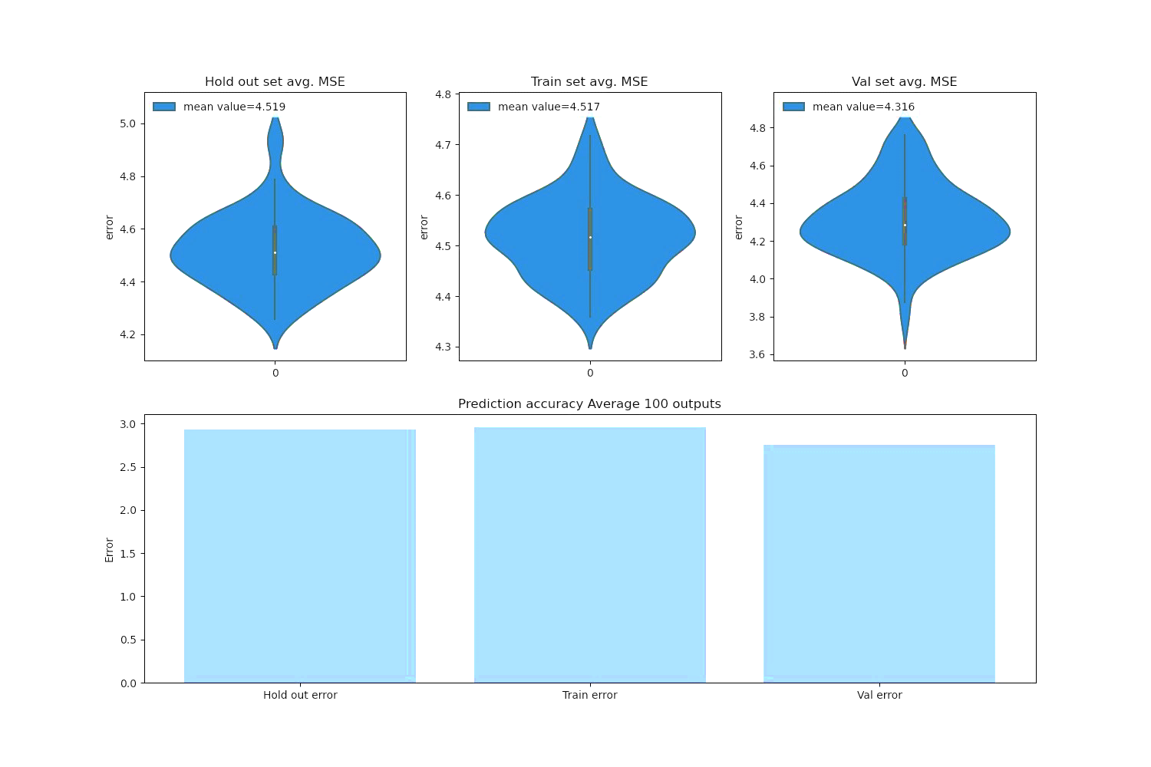

Figure 1: Model metrics over hold out, training and evaluation data sets

### 4.2 The statistical inference model

To evaluate the results of the performed deep learning analysis, a statistical inference analysis is performed for each country. For each influencing input factor, the distribution of pandemic growth rates, in the days where the selected explanatory factor has been active, is compared with the distribution of the pandemic growth rates in the days where the selected explanatory variable has not been active. To obtain the posterior probabilities with regard to presence and not-presence of a selected factor, we analyze the data based on a hierarchical Bayesian model (Congdon, 2019; Johnson et. al., 2022). A hierarchical Bayesian model considers a hyper parameter at the top level of its analysis, as well as specific parameters in its lower level. The top hierarchical level takes the overall distribution of growth rates in a country into account regardless of the condition whether a certain factor E has been active or not. The lower level takes the situation-specific developments into account i.e. whether the selected influential factor is implemented or not. The Bayesian model code and its assumption regarding the distribution functions of the prior data are attached to the supplementary material of the paper. The sampling procedure of the posterior distributions are accomplished via using No-U-turn sampler (NUTS) implemented in the probabilistic programming package for python PyMC3. The technical details are explained in the supplementary material. Thereby, we use the information regarding the 7 days’ average backward and 7 days’ average forward number of the reported infections at any arbitrary dayfor each country from the *data_encoded.* If the average number of observed SARS-CoV-2 positive cases 7 days before any day *i*, is equal to and the average number of observed SARS-CoV-2 positive cases 7 days after the day *i* is equal to , n=7 , then, the *daily* based variable is defined according to equation (2):

(2)

represents a kind of *symmetric* predictive criteria to indicate the change in the spread of the virus between 7 days’ average backward and 7 days’ average forward at any arbitrary day *i*. is the *daily growth rate* of the pandemic.

We define *efficiency* of a factor to be the probability that the presence (activation, “+”) of a factor, in comparison to the absence (non-activation, “-“) of that factor within an arbitrary chosen day, grants less value of growth rate of the virus. Before formalizing the definition of efficiency in equation 3, Figure 2 and Figure 3 illuminate the inference procedure from the observed data (left column of Figure 2) to obtain posterior predictive distributions of growth rates (middle and right hand columns of Figure 2) and to compute the efficiencies (Figure 3) by means of the example of “*closure of gyms and sport centers*” in the four most populated European countries (France, Germany, Italy and Spain).

We first distinguish between the days, where the selected factor (“closure of gyms and sport centers” in Figure 2) has been active (blue line at the left hand side of Figure 2) in each selected country, and those days, where the selected factor has not been active (orange line at the left hand side of Figure 2) in that country. The posterior predictive probabilities in the middle and the right hand side of figure 2 are driven by sampling posteriors from the prior data existing in the left hand sided of Figure 2.

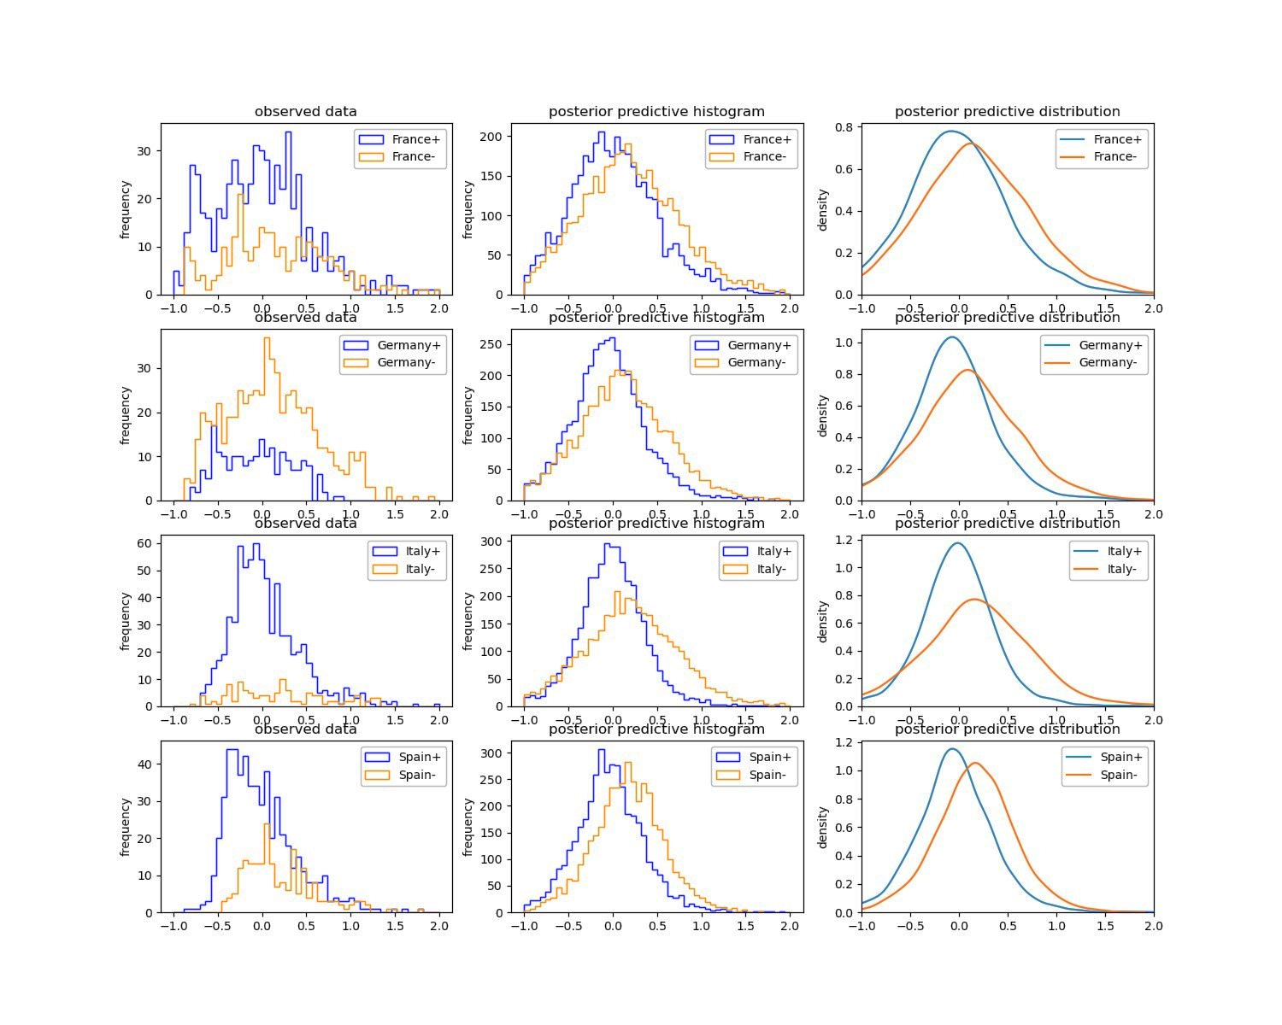

Figure 2: Posterior predictive results regarding activation (“+” - positive sign) versus non-activation (“-“ - negative sign) of the explanatory factor of “closure of gyms and sport centers” in the four most populated European countries

The distinguished (positive-signed and negative-signed) probability lines as well as density curves at the middle and right hand side columns of the Figure 2 can be used to compare the *efficiency* of activation versus non-activation of the selected explanatory factor. Though, a precise statistical comparison between the outcome of each blue (positive signed) distribution and each orange (negative signed) distribution is carried out by 1000 times sampling 1000 random draws from both blue and orange distributions and looking each time, whether the probability of is *smaller* in the predictive (blue) distribution (representing the activation of the selected factor) compared to in the predictive (orange) distribution (representing the non-activation of the selected factor). In other words, each time (from 1000), 1000 random draws from the positive signed posterior distribution will generate a list *L* of named , which is of length 1000. Likewise, each time (from 1000) we do 1000 random draws from the negative signed posterior distribution and generate a list of named , which is of length 1000. Then, the efficiency ratio expressed in equation 3 results from the comparison of each positional element *i* of the above mentioned two generated lists in being 1 if true and 0 if false in equation 3.

(3)

Based on equation (3), the explanatory variables with efficiency values larger than 50 percent can be labeled as *effective* with regard to the growth rate. The histogram of the obtained 1000 computed efficiencies for the countries of figure 2 is depicted in figure 3.

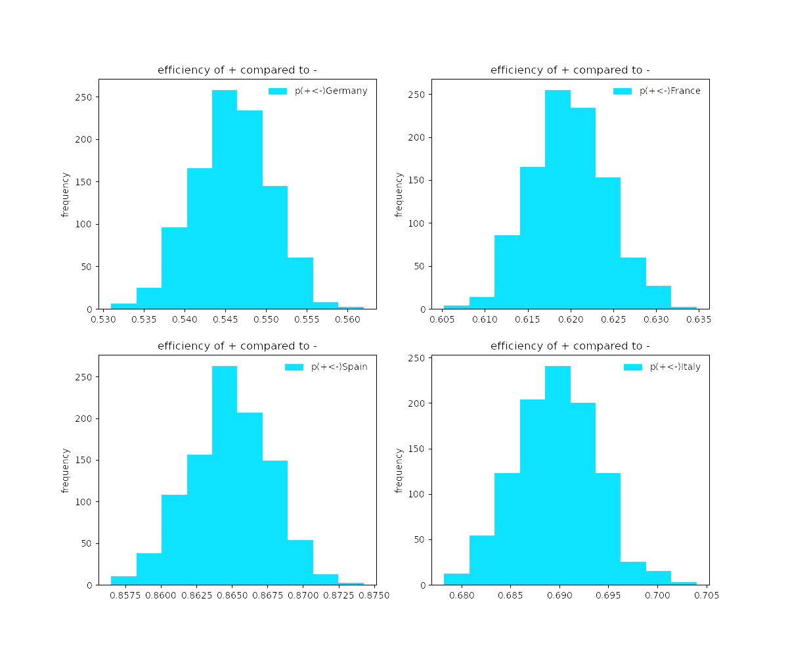

Figure 3: Efficiency of the implementation of the selected NPI (gyms and sport centers closures) in comparison to non-implementation of it within the selected subset of countries

The detailed results regarding the summary of explanatory factors’ efficiencies and the corresponding statistics are attached to the supplementary material of this paper. The relevant convergence criterion i.e. *r-hat* statistic in all obtain results are close to 1.00 for all parameters, i.e. can be considered precise enough. We conclude that there are no problems during sampling.

### 4.2 The XAI model

We employ two explainable ML algorithms introduced in the following two subsections to understand the significance and magnitude of each explanatory factor of our study.

#### 4.2.1 PFI

In order to assess the importance of each input feature (explanatory variable) on the predicted reproduction rate of the virus in the DNN model, we apply one of the well-known explainable machine learning algorithms i.e. the permutation feature importance PFI algorithm based on Fisher, Rudin, and Dominici (2018). The PFI algorithm is attached to the supplementary material of the paper. Thereby, one can estimate the significance of each input feature (explanatory variable) by calculating the increase in the model’s initial prediction error after permuting (shuffling) that feature within all rows of a selected set of data (hereby random 25% of the entire dataset).

#### 4.2.2 PDP

To shed light on the marginal effect each relevant input feature might have on the predicted outcome of the DNN model, we also apply one of the well-known explainable machine learning algorithms i.e. partial dependence plot PDP algorithm (Friedman, 2001). In order to compute the average partial dependence function of a *certain value* of an explanatory factor, we estimate the average prediction of all days of a selected set of data (hereby country wise), if all daily values regarding that factor are set to the mentioned certain value. By means of the PDP we aim at understanding two distinct *counterfactual* scenarios, in which one selected input factor could be turned to be 1 (representing its activation within all days in the data of a country) or be turned to zero (representing its inactivation within all days in the data of a country). We do this procedure country-wise over the entire existing data of each of the thirty countries’ data sets. For each explanatory factor and each country, we then subtract the predicted value related to the counterfactual inactivation of that factor (representing the predicted monthly reproduction rate by setting that feature to zero) from the predicted value related to the counterfactual activation of that feature (representing the predicted monthly reproduction rate by setting that feature to one). If the subtracted value is greater than zero, then the average predicted reproduction rate will be lower under the counterfactual scenario of the values of that factor being active on all days of the pandemic time span in the corresponding country. Analogously, negative subtracted values indicate greater predicted reproduction numbers under the counterfactual scenario of the values of that factor being active on all days of the pandemic time span in the corresponding country.

## Results of importance and marginal effects of the explanatory variables

Due to the high length of the feature numbers, the resulted PFI importance of variables is presented in Figure 4 on two side-by-side panels. [The right panel is indeed the continuation of the left hand side one.] The features at the bottom of the left hand side panel can be interpreted as the ones with lower importance values and the features at the top levels of the right hand side panel are the ones with the highest importance values. The *Base line*, which represents the zero importance line, lays around the bottom of the left hand side panel between some not frequently observed virus variants i.e. *BA.2+L452X* and *BA.4/BA.5*.

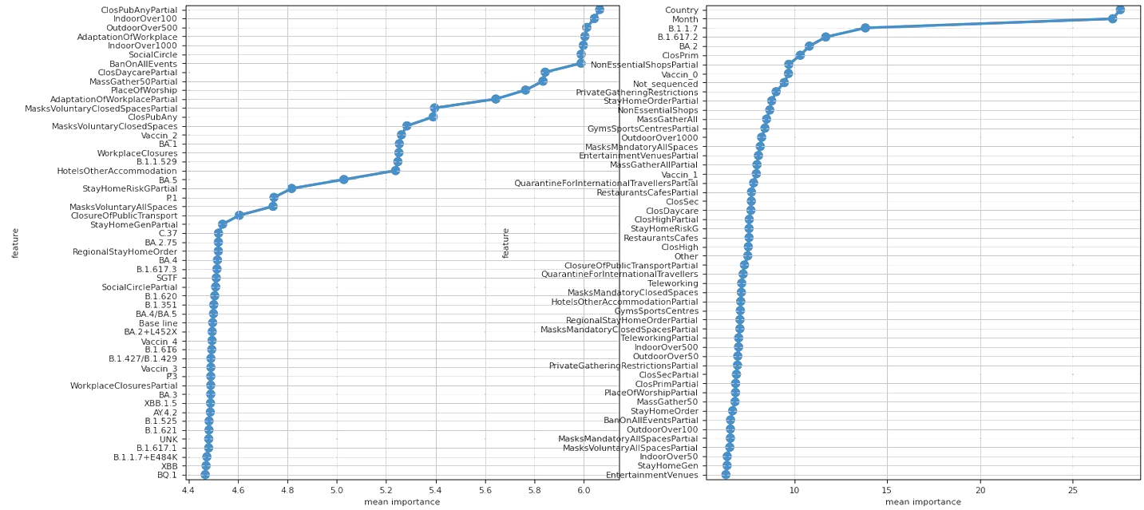

Figure 4: Importance of explanatory variables with regard to their impact on the pandemic reproduction (bottom of right hand side panel continues from top of the left hand side panel)

The depicted values on the plot in Figure 5 express average gains measured in terms of alteration of reproduction values to contain the pandemic growth, if one feature is active in comparison with the circumstance of that feature being non-active in line with the PDP notion.

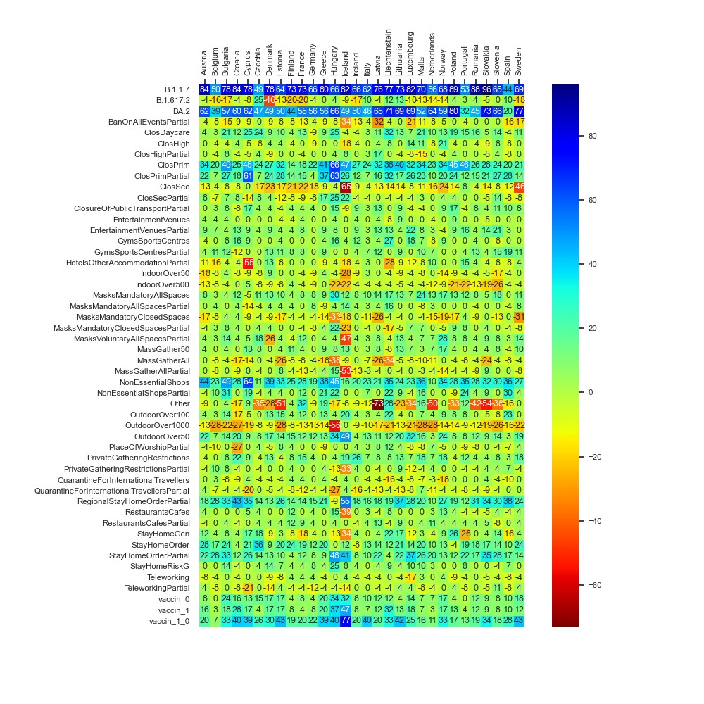

Figure 5: Average gains expressed in terms of difference of reproduction values, when activating each feature in each of the thirty countries, for which data is available

Figure 6 illustrates the month-wise computed PDPs covering the counterfactual scenarios of all months of the year being set each time to a specific month ranging from 0 (December) to 11 (November). In Figure 6, a specific period of the year for each country between the month 4 (April) until the month 9 (September) is light-red highlighted as it demonstrates the season relatively belonging to the warmer times within the year.

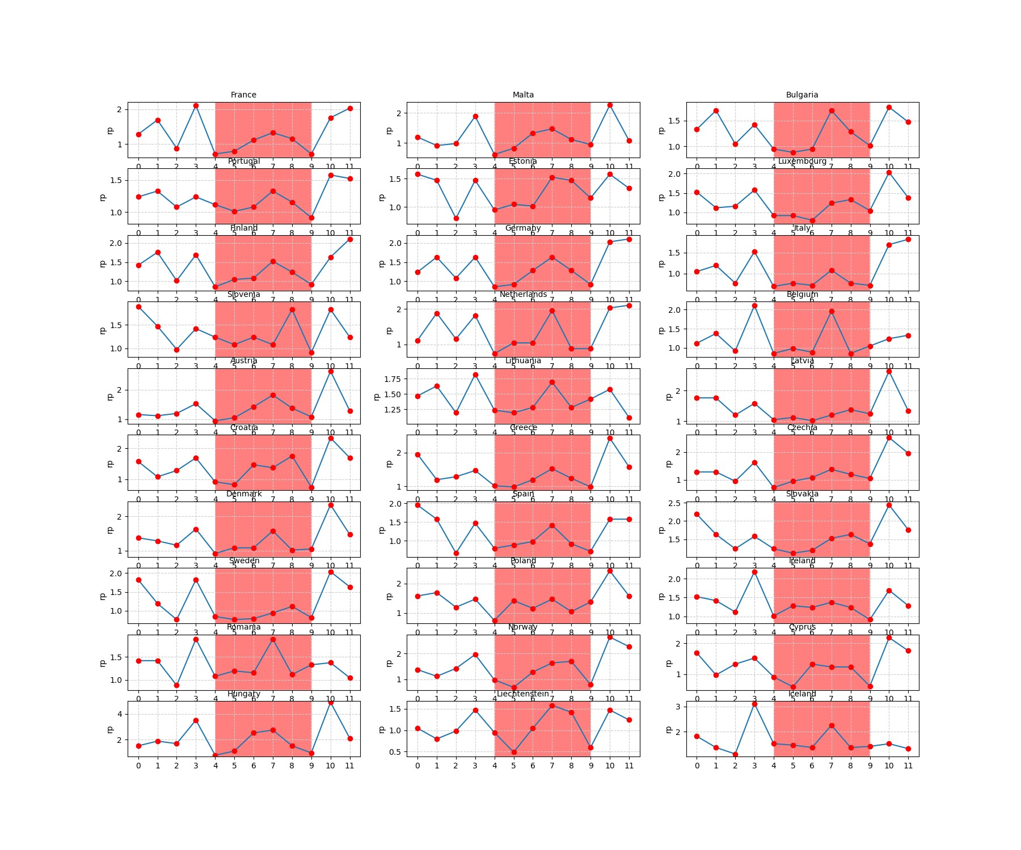

Figure 6: Monthly predicted average reproduction values for European countries within a time-span of 12 months

We then examine the obtained results of the DNN model by looking at the outcomes of the *statistical inference* model. Figure 7 demonstrates the average values corresponding to each explanatory factor’s efficiencies from the statistical inference analysis. [The max and min values of differ in the range of maximal 2 percent from the depicted mean values and are represented in supplementary material.]

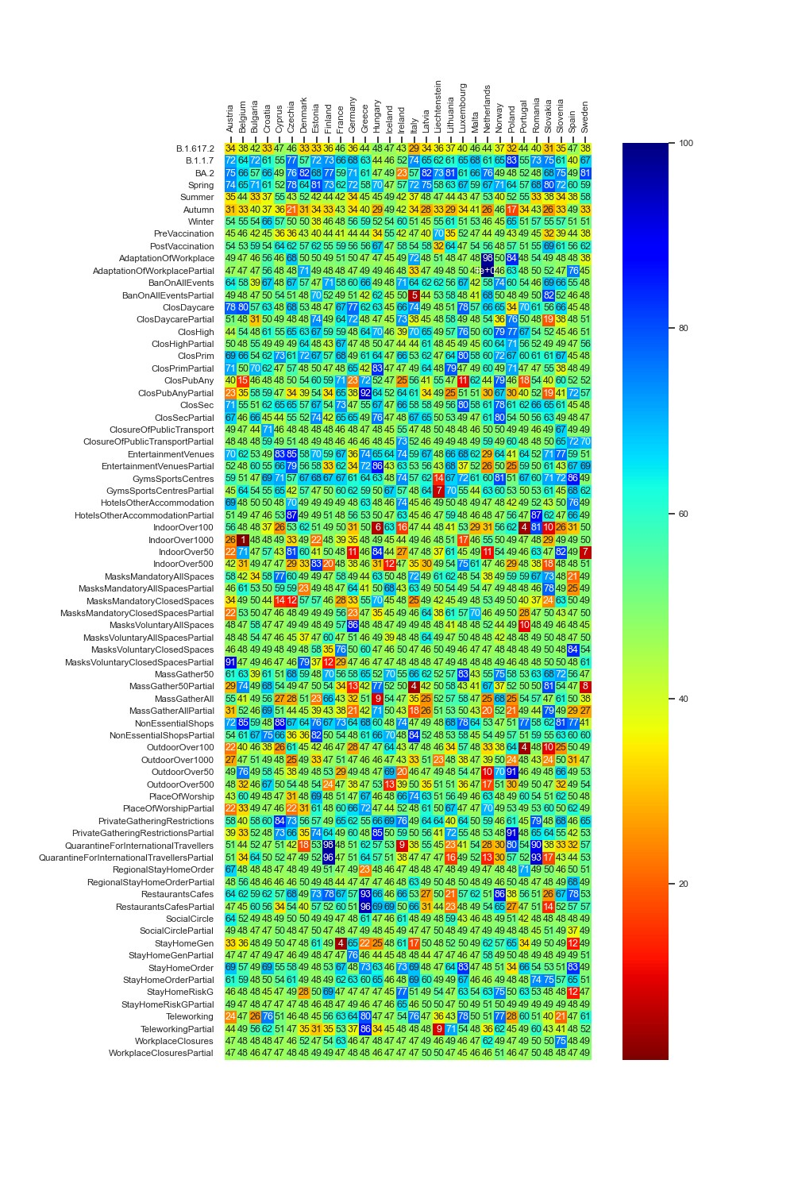

Figure 7: Summary of each explanatory factors’ average efficiency in percentage values.

In order to summarize the statistical inference for each explanatory variable (depicted in Figure 7), the average of the efficiencies over the entire 30 countries are computed and demonstrated in Figure 8. As with Figure 4, the resulted *averaged efficiency* terms in Figure 8 are presented in two side by side panels. The right panel is indeed the continuation of the left hand side one. The factors on the left hand side panel are those which are characterized by under 50 percent efficiency values and can be labeled as *effective* with regard to the pandemic *growth*. In contrast, the factors on the right hand side panel are those, which are characterized by larger than 50 percent efficiency values and can be labeled as *effective* with regard to the pandemic *control*. Hence, the factors at the bottom of the left hand side panel (e.g. the season Autumn or the omicron variant) can be interpreted as the ones with the largest pandemic progression efficacy and the factors at the top of the right hand side panel (e.g. the season Spring and the alpha variant) can be interpreted as the ones with the largest pandemic control efficacy from the statistical inference point of view.

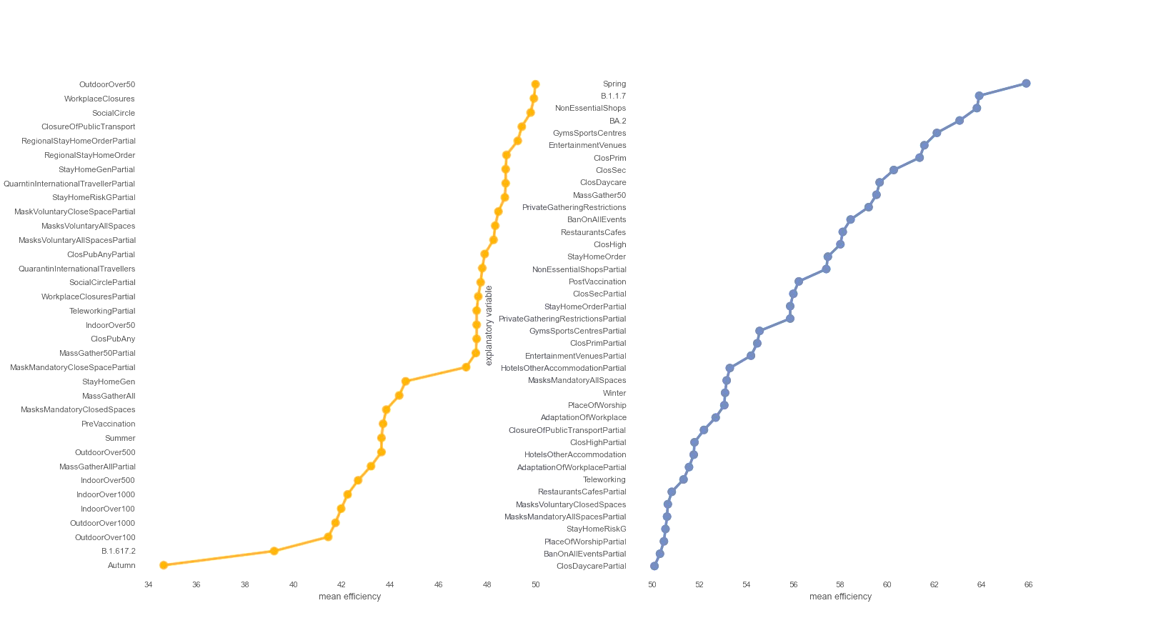

Figure 8: Sorted average efficiencies of the pandemic influential factors over all studied countries.

## Discussion and interpretation of findings

The analysis of the importance of explanatory factors (Figure 4) indicates that the factor *country* is at the top level of influential factors on the predictions of the model. The factor *country* being that important is because, by constructing the DNN model, this factor is not averaged over different countries as it does not make sense. Each country is a unique key for the data solely corresponding to that country. It remained on its place during the training of the model. However, seeing the factor *month*, which is well taken into account during the training procedure of the BCNN model, at the top of all other explanatory features is remarkable.

Consequently, we conclude that the months and seasons have been much more influential on the dynamics of the SARS-CoV-2 pandemic in comparison with the governments NPIs, vaccination policies as well as emergence of virus mutants. The evidence from the counterfactual PDP exploration of seasonal effects (Figure 6) is twofold: *First*, the overall reproduction rates in the white area are significantly higher than those ones within the light red area. *Second*, in most of the countries there is a peak in the virus spread around the *month 7* (July). Existing literature explores the role of seasonal trends. Merow and Urban (2020) develop statistical models that predict the maximum potential of COVID-19 worldwide and throughout the year. The authors predict that COVID-19 will decrease temporarily during summer, rebound by autumn, and peak next winter. In a more recent study, Wiemken et. al. (2023) use time series decomposition to extract the annual seasonal component of COVID-19 cases, hospitalization, and mortality rates from March 2020 through December 2022 for the United States and Europe. The authors identify seasonal spikes in COVID-19 from approximately November through April for all outcomes and in all countries. These results are indeed to a large extent in line with the predictions of our deep learning model. In addition, the results of the statistical inference analysis (Figure 7 and Figure 8) regarding the seasonality effects approve that large probable growth rates of the virus are visible in the season Autumn (September, October and November) and the smallest pandemic growth is predicted to be in the season Spring (March, April and May). The statistical inferences show that the gained efficiencies in Winter (December, January and February) are higher than the efficiencies of Summer (June, July and August). [Note that as the statistical inference analysis uses the data of each country separately, the months are summarized into the seasons so to increase the number of prior observations per season in each country.] Returning to the spike in July in the DNN model (Figure 6), the frequently observed peak in summer in most of the countries (e.g. Hungary in July, Liechtenstein in July-August, Belgium in July, Bulgaria in July, Estonia in July-August, Netherlands in July, Lithuania in July etc.) can be hypothesized to be a result of the surge in the infection cases through less restricted public mobility during summer vacation.

The deep neural network model as well as the statistical inferences both evidence that the three well-known variants of the virus (i.e. *B.1.1.7 - Coronavirus Alpha variant*, *B.1.617.2 - Coronavirus Delta variant,* and *BA.2 - Coronavirus Omicron variant)* have seemingly played a significant role on driving the dynamics of the pandemic, i.e. higher influence on the virus spread than the governments NPIs and vaccination programs. The PDP analysis of the DNN model (Figure 5) also evidences that, in the light of the assumption regarding the counterfactual scenario of the pandemic getting stuck by the mere presence of *B.1.1.7 (Coronavirus Alpha variant*), a considerable amount of reproduction rate reduction of up to around 90 percent could have been achieved. The rows of Figure 5 regarding the *B.1.617.2 (Coronavirus Delta variant)* and *BA.2 (Coronavirus Omicron variant)* reveal, to what extent the counterfactual predominance of the Omicron variant could have been beneficial in terms of amelioration of the virus spread and how the hypothetical extension of the delta variant could be harmful.[ Note that a row named ‘Others’ exists, which indicates the potential harmful effect of other not labeled virus variants in the data set, if such virus variants could prevail the pandemic scene, which might have gone beyond the destructive role of the delta variant.] The same inferences regarding the role of the major virus variants can be obtained through the statistical inference analysis (see Figure 7 and Figure 8).

While the outcomes disclose the role of the explanatory factors within each country separately, the overall results indicate that, generally, the government policies might have played a subordinated role compared to the seasonality and virus variants.

Figure 5 and Figure 7 illustrate that, in the majority of countries, the efficiency of the post vaccination period is relatively higher than the pre vaccination period. The factor *vaccine_0_1* in Figure 5, which expresses the counterfactual scenario of the whole population being vaccinated by the first and the second dose within all phases of the pandemic, reveal the *relative* successfulness of the vaccination policy to constrain the spread of the virus.

Beyond the month and season factors, of the NPIs, especially closing the primary schools, *general* and *regional* lockdowns, and non-essential shops closures were significant in reducing the pandemic reproduction, both in the DNN model and the statistical inference model.

While in the literature, the effects of government mask mandates are to some extent inconsistent (Leech et. al., 2022), the *partially* inconstant representation of the mask mandates in *closed* spaces in Figure 5, Figure 7 and Figure 8 need to be further researched. The explanatory factor *MasksMandatoryAllSpaces* encompassing the protective mask usage in all public spaces on mandatory basis (enforced by law) is predicted through the DNN model to have positive influence to combat the pandemic. However, it is peculiar that the factor MasksMandatoryClosedSpaces representing protective mask use in closed public spaces/transport on mandatory basis (enforced by law) is rather contributing to increase infection rates in most of the countries.

This requires further research on the role of mask mandates to control the pandemic. Kai et al put forward some hypothesis that enforcing masks works if and only when the entire or at least a substantial mass of the society becomes committed to it. And it becomes significantly inefficient if mask wearing is prescribed or obeyed partially (Kai et. al., 2020) or if the observed levels of mask wearing in closed spaces are critical (Leech et. al., 2022). Barceló and Sheen raise the question of effectiveness of mask mandates in regions, where commitment to face masks lacks cultural background (Barceló & Sheen, 2020). Despite that conjectures, examining the predicted non-efficiency of mask mandates in *closed spaces,* despite the high efficiency of *all spaces* mask mandates, as shown in Figure 5, Figure 7 and Figure 8 might not be explained completely based on the above hypothesis nor within our analysis. It requires further research.

## Conclusion

This paper applies a deep Bayesian convolutional neural network to analyze the SARS-CoV-2 government policies over thirty European countries. The data explored indicates 66 government measures, virus variant distributions of 31 virus types, the vaccinated population percentages by the first 5 doses as well as the reported daily new infections in each country. As the deep learning model can be interpreted as a black box approach, we take a closer look at the empirically observed statistics for each explanatory factor by means of a Bayesian statistical inference analysis. The statistical inference analysis compares two distinct circumstances for each explanatory influential factor: a) the (predictive) distribution of pandemic growth rates when the selected factor was active, and b) the same indicator when the selected factor was not active, respectively. We then compute the probability of whether and to which degree activating the selected factor in comparison to non-activating of it results in fewer values of growth rates. The results of the deep learning Bayesian model and the statistical Bayesian inference overlap to a large extent. While the outcomes disclose the role of government interventions within each country separately, the overall results indicate that, generally, a number of government policies played a subordinated role compared to the seasonality and virus variants. The seasonality effects shaped the overall dynamics of the pandemic as an influential factor on top of the influence sphere of other pandemic explanatory factors. Large growth rates of the infections are achieved around the season Autumn (especially in October and November) and the smallest probabilities with regard to the pandemic growth is in the season Spring (especially in April and May). This does not contradict the positive impact of some important NPIs and vaccination policies. The role of the first two vaccination doses as well as the NPIs closing the primary schools, *general* and *regional* lockdowns, and non-essential shops closures substantially contributed to the reduction of the spreading of the virus. This is evidenced both from the Bayesian deep learning model as well as from the Bayesian statistical inference analysis.

Despite targeting to be comprehensive, the analysis of this paper has its limits. It does not incorporate the degree of government's NPIs appliance or the degree of people's compliance with the governments’ NPIs interventions through different regions and phases of the pandemic. Moreover, some intervention policies - such as contact tracing measures data or the role of media and communication policies - were not integrated in our data set. Likewise, the role of temperature is just implicitly represented by means of seasons and months.

There are further model improvement opportunities to enhance our approach’s reliability. First, where the factor time is just implicitly modeled in our study through averaging the effect of each explanatory variable over a month, we adopt a 2 dimensional input data vector to explicitly model the connected time steps as one axis along with the set of explanatory variables in a second axis in our next work. Second, the role of country specific covariates can be added to the set of explanatory factors of this study to elaborate more on the differences between countries. Finally, further explainable machine learning XAI methods can be applied to ensure the results from additional different perspectives.

## List of abbreviations

|  |  |
| --- | --- |
| AI | Artificial intelligence |
| BCNN | Bayesian convolutional neural network |
| BNN | Bayesian neural network |
| CNN | Convolutional neural networks |
| DNN | Deep neural network |
| NPI | Non pharmaceutical interventions |
| NUTS | No-U-turn sampler |
| PDP | Partial dependency plot |
| PFI | Permutation feature importance |
| PI | Pharmaceutical interventions |
| SARS‑CoV‑2 | Severe acute respiratory syndrome coronavirus 2 |
| XAI | Explainable artificial intelligence |

## Acknowledgement

This research has been conducted as part of the Covid&AI project, which is funded by Ministry of Science and Health of Rhineland-Palatinate, Germany. We acknowledge the fruitful discussion along presentations of the work in our joint workshops of the four research groups at the University of Koblenz.

## Supplementary material

The datasets analyzed during the current study are available in the European Centre for Disease Prevention and Control data repository,

https://www.ecdc.europa.eu/en/data/downloadable-datasets

Further material such as code, data, results and figures related to this paper can be found in the GitLab account, provided by University of Koblenz.

## Conflict of interest

All authors have no conflicts of interest.

## References

1. Alassafi, M.O. , Jarrah, M., Alotaibi, R. Time series predicting of COVID-19 based on deep learning Neurocomputing, 468 (2022), pp. 335-344, 10.1016/j.neucom.2021.10.035
2. Banholzer, N., Feuerriegel, S. & Vach, W. Estimating and explaining cross-country variation in the effectiveness of non-pharmaceutical interventions during COVID-19. Sci Rep 12, 7526 (2022). https://doi.org/10.1038/s41598-022-11362-x
3. Barceló J, Sheen GC. Voluntary adoption of social welfare-enhancing behavior: Mask-wearing in Spain during the COVID-19 outbreak. PLoS One. 2020 Dec 1;15(12):e0242764. doi: 10.1371/journal.pone.0242764. PMID: 33259531; PMCID: PMC7707551.
4. Binggui, Z., Guanghua, Y., Zheng, Shi., Shaodan, M., Interpretable Temporal Attention Network for COVID-19 forecasting, Applied Soft Computing, Volume 120, 2022, 108691, ISSN 1568-4946, https://doi.org/10.1016/j.asoc.2022.108691.
5. Bishop, C.M. ( 2006). Pattern recognition and machine learning. New York :Springer
6. Chirwa, G.C., Zonda, J.M., Mosiwa, S.S. et al. Effect of government intervention in relation to COVID-19 cases and deaths in Malawi. Humanit Soc Sci Commun 10, 335 (2023). https://doi.org/10.1057/s41599-023-01821-9
7. Duane, S., Kennedy, A. D., Pendleton, B. J.; Roweth, D. Hybrid Monte Carlo. 1987. Physics Letters B, Volume 195, Issue 2, p. 216-222. DOI:10.1016/0370-2693(87)91197-X
8. Damette, O., Huynh, T.L.D. Face mask is an efficient tool to fight the Covid-19 pandemic and some factors increase the probability of its adoption. Sci Rep 13, 9218 (2023). https://doi.org/10.1038/s41598-023-34776-7
9. Fisher, A., Rudin, C., Dominici, F. “All models are wrong, but many are useful: Learning a variable’s importance by studying an entire class of prediction models simultaneously.” http://arxiv.org/abs/1801.01489 (2018).
10. Flaxman, S., Mishra, S., Gandy, A. et al. Estimating the effects of non-pharmaceutical interventions on COVID-19 in Europe. Nature 584, 257–261 (2020). https://doi.org/10.1038/s41586-020-2405-7
11. Ge, Y., Zhang, WB., Wu, X. et al. Untangling the changing impact of non-pharmaceutical interventions and vaccination on European COVID-19 trajectories. Nat Commun 13, 3106 (2022a). https://doi.org/10.1038/s41467-022-30897-1
12. Ge, Y., Zhang, W.B., Liu H., Ruktanonchai, C.W., Hu, M., Wu, X., Song, Y., Ruktanonchai, N.W., Yan, W., Cleary, E., Feng, L., Li, Z., Yang, W., Liu, M., Tatem, A.J., Wang, J.F., Lai, S. Impacts of worldwide individual non-pharmaceutical interventions on COVID-19 transmission across waves and space. Int J Appl Earth Obs Geoinf. 2022b Feb;106:102649. doi: 10.1016/j.jag.2021.102649. PMCID: PMC8666325.
13. Huy, L.D., Nhi Thi Hong, N., Phan Thanh, P., and Chung-Chien, H. "The Effects of Non-Pharmaceutical Interventions on COVID-19 Epidemic Growth Rate during Pre- and Post-Vaccination Period in Asian Countries" International Journal of Environmental Research and Public Health 19, no. 3: 1139 (2022). https://doi.org/10.3390/ijerph19031139.
14. Johnson A. A., Miles Q. Ott, Mine Dogucu. Bayes Rules! An Introduction to Applied Bayesian Modeling https://doi.org/10.1201/9780429288340
15. Kamineni, M., Engø-Monsen, K, Midtbø, J.E., Forland, F., de Blasio, B.F., Frigessi, A. , Engebretsen, S. Effects of non-compulsory and mandatory COVID-19 interventions on travel distance and time away from home, Norway, 2021 Eurosurveillance, 28, 2200382 (2023), https://doi.org/10.2807/1560-7917.ES.2023.28.17.2200382
16. Kai, D., Goldstein, G., Morgunov, A., Nangalia, V., Rotkirch. A. Universal Masking is Urgent in the COVID-19 Pandemic: SEIR and Agent Based Models, Empirical Validation, Policy Recommendations. arXiv:2004.13553
17. Krizhevsky, A. Sutskever, I., Geoffrey, E. H. Imagenet classification with deep convolutional neural networks. In Advances in neural information processing systems, pages 1097–1105, 2012.
18. Liu, D., Ding, W., Sasha Dong, Z., Pedrycz, W. Optimizing deep neural networks to predict the effect of social distancing on COVID-19 spread,Computers & Industrial Engineering, Volume 166, 2022, 107970, ISSN 0360-8352, https://doi.org/10.1016/j.cie.2022.107970
19. Liu, Y., Yu, Q., Wen, H. et al. What matters: non-pharmaceutical interventions for COVID-19 in Europe. Antimicrob Resist Infect Control 11, 3 (2022). https://doi.org/10.1186/s13756-021-01039-x
20. Lawson, A., and Chawarat R. "Bayesian Spatio-Temporal Prediction and Counterfactual Generation: An Application in Non-Pharmaceutical Interventions in COVID-19" Viruses 15, no. 2: 325 (2023). https://doi.org/10.3390/v15020325
21. Leech, G., Rogers-Smith, C., Teperowski Monrad, J., Sandbrink, J.B., Snodin, B., Zinkov, R., Benjamin, Brownstein, J.S., Gal, Y., Bhatt, S., Sharma, M., Mindermann, S., Brauner, J.M., Aitchison, L. Mask wearing in community settings reduces SARS-CoV-2 transmission. 2022. https://www.pnas.org/doi/full/10.1073/pnas.2119266119
22. Lionello, L., Stranges, D., Karki, T., Wiltshire, E., Proietti, C., Annunziato, A., Jansa, J., Severi, E. Non-pharmaceutical interventions in response to the COVID-19 pandemic in 30 European countries. ECDC–JRC Response Measures Database Eurosurveillance, 27, 2101190 (2022), https://doi.org/10.2807/1560-7917.ES.2022.27.41.2101190
23. Li, M.L., Bouardi, H.T., Skali Lami, O., Trikalinos, T.A., Trichakis, N., Bertsimas, D. Forecasting COVID-19 and Analyzing the Effect of Government Interventions. Operations Research 71(1):184-201 (2022). https://doi.org/10.1287/opre.2022.2306
24. Merow, C., Mark, C. Urban, Seasonality and uncertainty in global COVID-19 growth rates, Proceedings of the National Academy of Sciences, 117(44): 27456-27464 (2020). doi: 10.1073/pnas.2008590117
25. MacKay, D. J. A practical Bayesian framework for backpropagation networks. Neural computation, 4(3):448–472 (1992).
26. Nguyen, M.H., Nguyen, T.H.T., Molenberghs, G. et al. The impact of national and international travel on spatio-temporal transmission of SARS-CoV-2 in Belgium in 2021. BMC Infect Dis 23, 428 (2023). https://doi.org/10.1186/s12879-023-08368-9
27. Nowak, S.A., Nascimento de Lima, P. & Vardavas, R. Optimal non-pharmaceutical pandemic response strategies depend critically on time horizons and costs. Sci Rep 13, 2416 (2023). https://doi.org/10.1038/s41598-023-28936-y
28. Pozo-Martin, F., Beltran Sanchez, M.A., Müller, S.A. et al. Comparative effectiveness of contact tracing interventions in the context of the COVID-19 pandemic: a systematic review. Eur J Epidemiol 38, 243–266 (2023). https://doi.org/10.1007/s10654-023-00963-z
29. Pung, R., Clapham, H.E., Russell, T.W. et al. Relative role of border restrictions, case finding and contact tracing in controlling SARS-CoV-2 in the presence of undetected transmission: a mathematical modelling study. BMC Med 21, 97 (2023).https://doi.org/10.1186/s12916-023-02802-0
30. Radford, M.N. Bayesian learning for neural networks. PhD thesis, University of Toronto, 1995.
31. Sinha, T., Chowdhury, T., Shaw, R.N., Ghosh, A. Analysis and prediction of COVID-19 confirmed cases using deep learning models: A comparative study, Advanced Computing and Intelligent Technologies, Springer, Singapore (2022), pp. 207-218, 10.1007/978-981-16-2164-2_18
32. Stokes, J., Turner, A.J., Anselmi, L. et al. The relative effects of non-pharmaceutical interventions on wave one Covid-19 mortality: natural experiment in 130 countries. BMC Public Health22, 1113 (2022). https://doi.org/10.1186/s12889-022-13546-6
33. Szegedy, C., Liu, W., Jia, Y., Sermanet, P., Reed, S., Anguelov, D., Erhan, D., Vanhoucke, V., Rabinovich, A. Going deeper with convolutions. arXiv preprint arXiv:1409.4842, 2014.
34. Verma, H., Mandal, S., Gupta, A., Temporal deep learning architecture for prediction of COVID-19 cases in India, Expert Systems with Applications, 195 (2022), Article 116611, 10.1016/j.eswa.2022.116611
35. Wiemken, T.L., Khan, F., Puzniak, L. et al. Seasonal trends in COVID-19 cases, hospitalizations, and mortality in the United States and Europe. Sci Rep 13, 3886 (2023). https://doi.org/10.1038/s41598-023-31057-1
36. Wen, Y., Vicol, P., Ba, J., Tran, D., Grosse, R. Flipout: Efficient Pseudo-Independent Weight Perturbations on Mini-Batches. Machine Learning. (2018). doi: https://arxiv.org/abs/1803.04386
37. Xu, L., Magar, R., Farimani, A.B., Forecasting COVID-19 new cases using deep learning methods Computers in biology and medicine, 144 (2022), Article 105342, 10.1016/j.compbiomed.2022.105342
38. Webster, J., & Watson, R. T. (2002). Analyzing the Past to Prepare for the Future: Writing a Literature Review. MIS Quarterly, 26(2), xiii–xxiii.
39. Yamashita, R., M. Nishio, R. K. G. Do, and K. Togashi. 2018. Convolutional neural networks: An overview and application in radiology. Insights into Imaging 9 (4):611–29. doi:10.1007/s13244-018-0639-9.